Energy conversion/optimization.

Working group: Jack and Tomas.
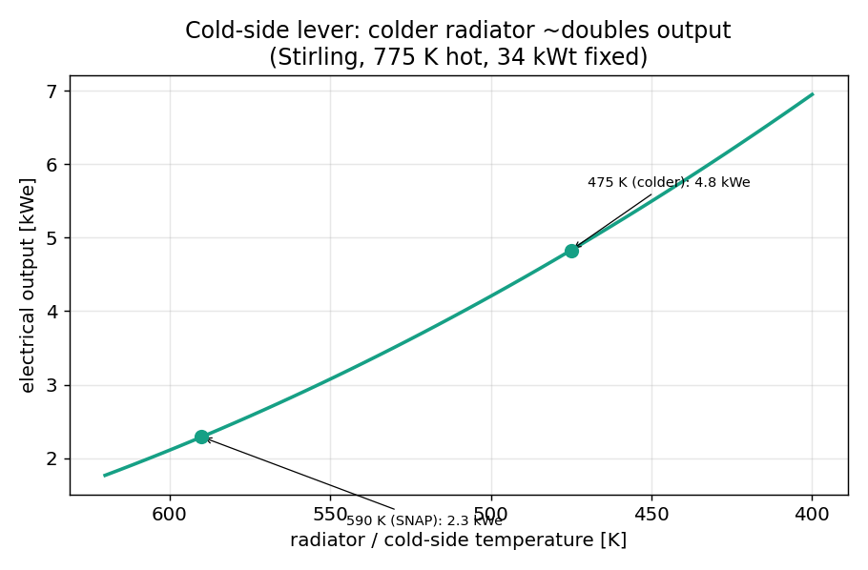
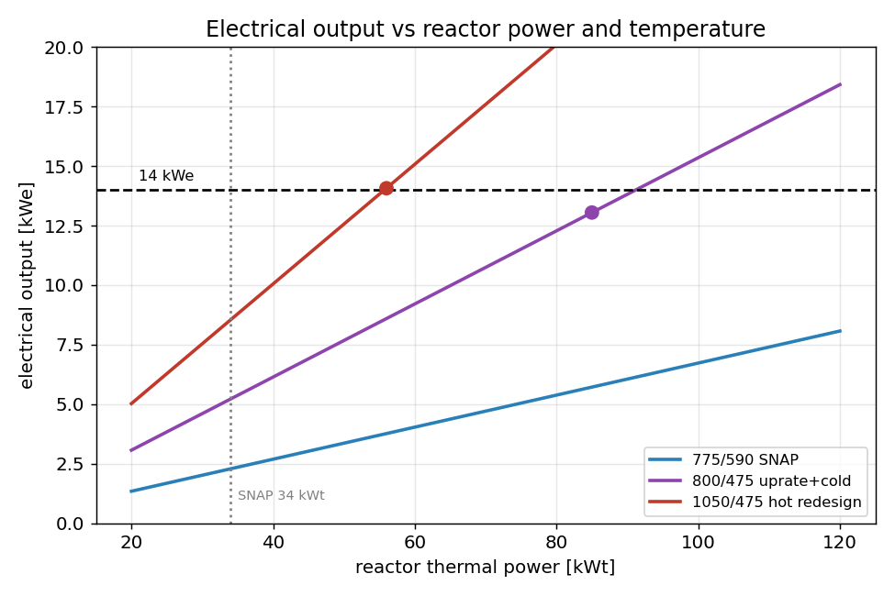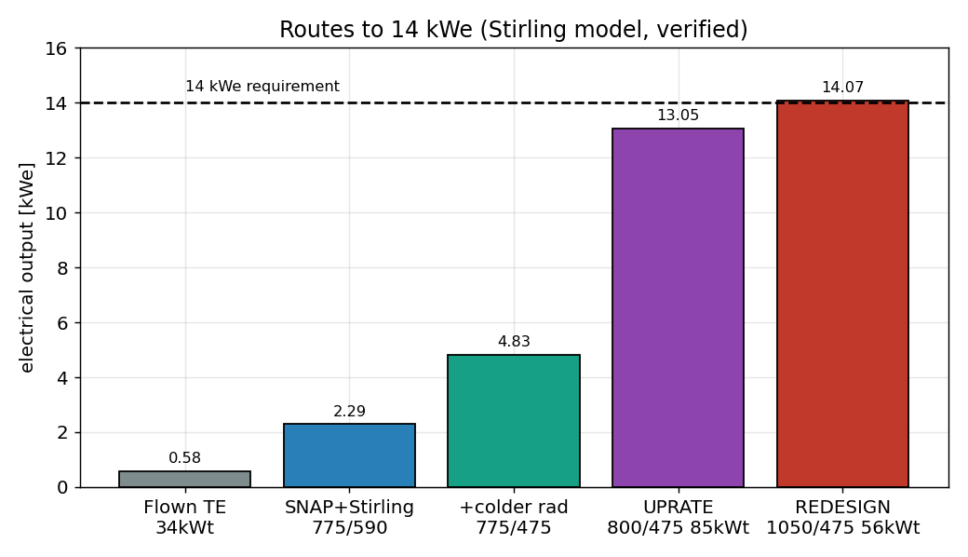

Fuel design and optimization

W
Table 1: Comparation of the most typical fuels and its parameters[1].
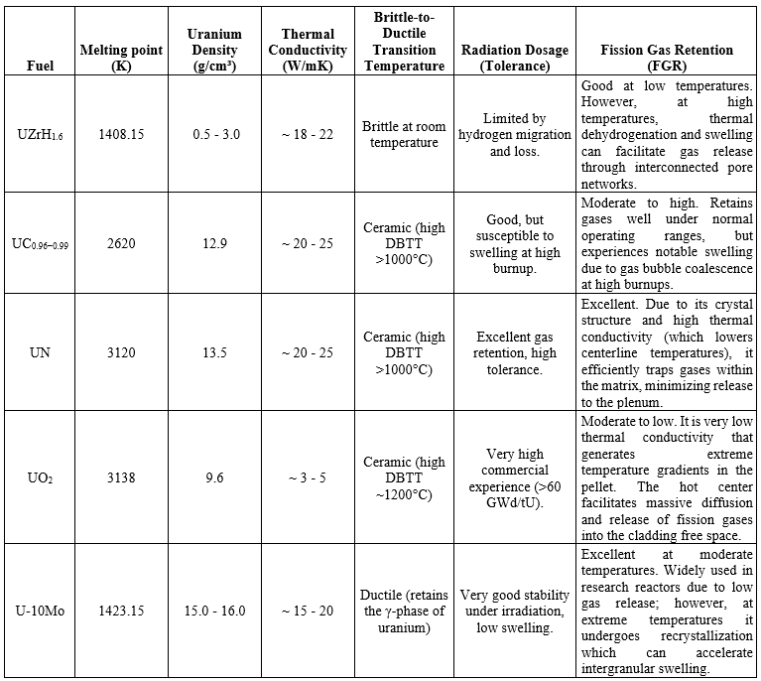

There are two forms of fuels: alloys that mix the U²³⁵ in the metal form into a matrix composed of other metals and the compound in which the metals are forming a periodic crystalline structure. Table 1 shows the most important properties of the typical fuels to be used in the fission reactor systems. Based on this table we can explore the possibility of the application based on the reactor conditions. In this Table we explore:
The most important parameter under consideration is the melting point. When we think about fission fuels, we need a material that can be solid even at a high temperature.

Different alloys and compounds have different uranium concentration depending on the purpose of the reactor and if the Uranium is highly enriched or low enriched. Natural uranium has a concentration of ~1% of fissile U²³⁵, the rest is U238 which is the most stable form of uranium. If we are talking about highly enriched uranium we need to have >20% of U²³⁵ and we don’t need too much amount of material compared with the low enriched uranium.
Thermal conductivity
Uranium by itself shows a high thermal conductivity, but compounds or alloys that will be used as fuel need to show also high thermal conductivity. Different materials are more resistant to conduct heat. In the metals form the heat is conducted by the free electrons, but in a compound or alloy with a higher dielectric constant the heat is mediated by phonons. These phonons are quasiparticles in the solid that show the coupled vibrations of the atoms in the materials. The defining equation for thermal conductivity is .
Brittle-to-Ductile Transition Temperature (BDTT)
This temperature defines the point when a metal changes its brittle nature in that can suffer a fracture without a significant plastic deformation to a ductile material. Figure 1 shows the graph of DBTT of some metals. This transition temperature normally occurs when the material changes its crystalline structure from a Face center cubic (FCC) to a body center cubic (BCC) unit cell with less packaging factor[2].
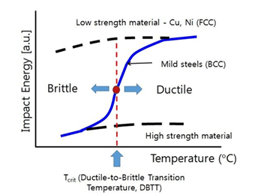
Figure 1. Brittle to ductile transition diagram that shows the change of phase and the mechanical properties by change of temperature.
Fission gas retention
One of the problems of the fission process of uranium is the formation of fission gases. These byproducts can cause damage to other components of the core makes it fail and cause leakage. Different alloys and compounds have different behaviors to retain these fission gases and is well known that it creates bubbles that can be allowed in the grain edges of the material to finally escape to the cladding gap reducing the thermal conductivity of the fuel and the performance of the reactor and increasing the probability of cracking by the swelling of the fuel[3].
To improve the performance of the fuel we need to look at what properties we what in the reactor. The predominant factor is the steady-state generated power at certain temperatures. The inherent problems that people need to solve are the swelling rates and fission gas retention, both problems can produce mechanical stress and the eventual cladding failure. The team of Beausoleil and collaborators in 2023 postulated that if an alloy could maintain the γ-phase in the uranium from room temperature to high operational temperatures then the fuel will also exhibit the same fission gas retention and low swelling behavior that U-Mo shows at low temperatures.[4] The Kilopower Reactor Using Stirling Technology (KRUSTY) have a core with highly enriched U-Mo that produce 4 KWt at 800 C. In order to make performance in the SNAP-10A simulation model in openMC, we change the fuel information in the code by all those possible materials and extract the information and create a bigger picture of how those materials will behave under the SNAP-10A conditions. In Figure 2 it is easy to appreciate a difference in the brightness inside of the core, that is related to a high temperature by more neutronic collision events.
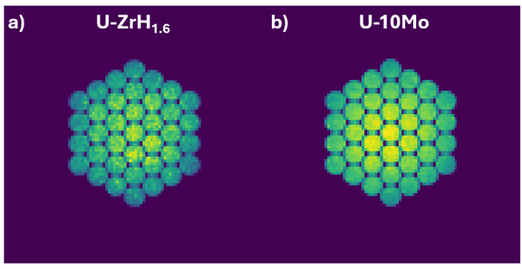
Figure 2. Comparation of the original SNAP-10A core of Uranium-Zirconium hydride (a) with 1000 batches and the same core changing the fuel by a Uranium-Molybdenum alloy (b) with the same number of batches.

Power conversion and the path to 14 kWe

This section covers the power conversion side of the system, the stage that turns reactor heat into electricity. Three questions drive it: what SNAP-10A actually converted and how well, what a modern dynamic converter would do on the same reactor, and what it would take to reach the 14 kWe that the current requirement sets. The work rests on the OpenMC model of the SNAP reactor, which fixes the heat available to the converter and the temperatures it has to work between, and on the original Atomics International converter report for the as-flown numbers.
The as-flown thermoelectric converter
SNAP-10A converted heat with a thermoelectric stage, a solid-state device with no moving parts. It used 1440 silicon-germanium couples in two parallel electrical paths, sitting between the NaK loop coming off the reactor and the radiator. A lumped model of that converter, built from the converter equations in report NAA-SR-11955 and fit to the report’s design point, reproduces its Table 2 to better than 0.2 percent on every quantity: 581 watts electric out, 28.5 volts, 1.82 percent overall efficiency, 7.65 percent at the device level, against a Carnot ceiling of 23.8 percent.[5] The energy balance closes independently. The cold-side heat rejection of 31.3 kilowatts is not fit to anything, and the model lands on it, so the agreement is a real check rather than a circular one.
The gap between the 7.65 percent the couples manage and the 1.82 percent the system delivers is physical, not a modeling loss. About 84 percent of the heat entering the converter conducts straight through the legs without being converted, because a thermoelectric leg has to conduct heat to hold a temperature difference across it, and conducting heat is exactly what wastes it. That single fact is why a static converter is reliable and why it is inefficient, and it is the reason every question that follows is really about giving up some reliability to recover that lost heat.
Thermoelectric versus Stirling on the same reactor
The cleanest way to size the opportunity is to hold the reactor exactly as the model has it, about 31.9 kilowatts of heat into the converter at a hot side near 775 K and a radiator near 590 K, and swap only the converter. Both a thermoelectric and a Stirling face the same 23.8 percent Carnot ceiling set by those two temperatures, so the one that captures more of it wins. A free-piston Stirling is a dynamic engine. It moves a fixed charge of helium between a hot space and a cold space and extracts the difference between hot expansion work and cold compression work, and a regenerator stores the gas heat on the way to the cold side and returns it on the way back so the cycle runs near Carnot. That regenerator is why a Stirling captures 30 to 46 percent of the ceiling where the thermoelectric captures under 8.
The Stirling here is held to SNAP’s temperatures, not to the much hotter conditions KRUSTY and Kilopower run at, because handing it KRUSTY’s hot end would compare two reactors rather than two converters.[6] Its efficiency is carried as a band, an optimistic case that holds Kilopower’s fraction of Carnot and a conservative case derated for SNAP’s smaller temperature ratio, since no one has run a Stirling at SNAP’s exact temperatures.[7] The results across that band are below.
Metric | Thermoelectric | Stirling, low | Stirling, high
Relative efficiency (of Carnot) | 7.7% | 30% | 46%
Overall efficiency | 1.82% | 7.1% | 11.0%
Electrical output | 581 We | 2278 We | 3493 We
Radiator area | 5.8 m2 | 5.4 m2 | 5.1 m2
Specific power | 8.3 W/kg | 43 W/kg | 59 W/kg

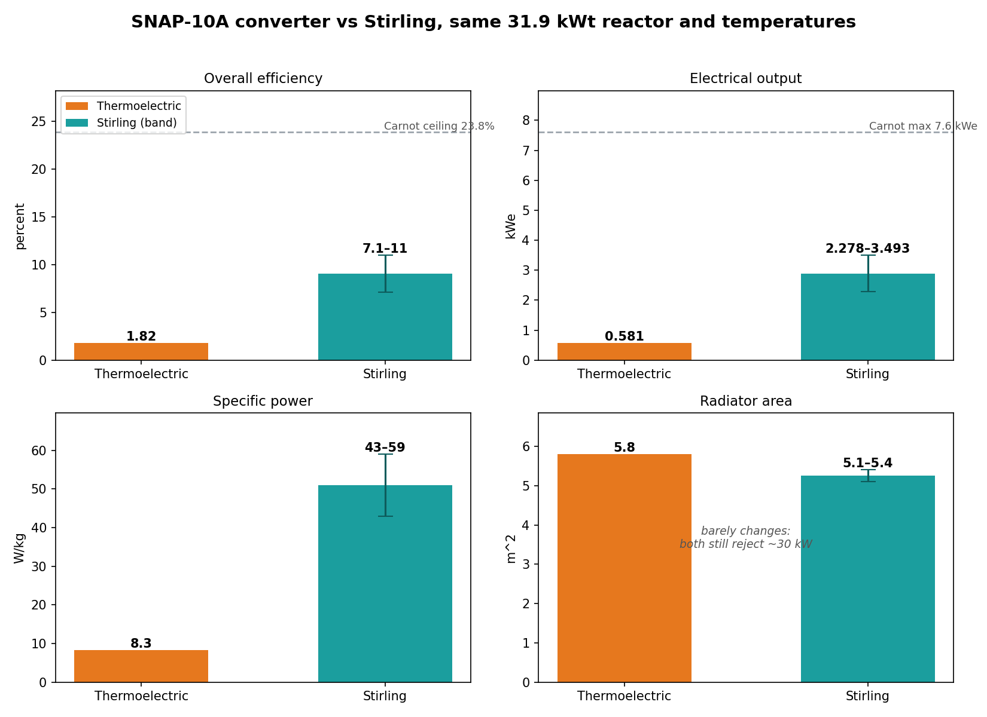
Figure 3. Thermoelectric versus Stirling on the same SNAP-10A reactor and temperatures. Overall efficiency, electrical output, specific power, and radiator area, with the Stirling carried as a band. The Stirling captures far more of the same Carnot ceiling, so it makes four to six times the electricity, while the radiator barely changes because both converters still reject most of the heat they take in.
A Stirling on the same reactor delivers 2.3 to 3.5 kilowatts electric against the thermoelectric’s 0.58, four to six times the electricity from the same reactor heat, and several times the specific power. The conclusion survives ignoring the soft mass estimate, because even at the full mass of the SNAP converter the Stirling still wins four to six fold, so the power gain carries it. The counterintuitive part is the radiator, which barely shrinks, from 5.8 to about 5.1 square meters. At SNAP’s modest temperatures both converters still reject most of the heat they take in, around 30 of the 32 kilowatts, so the radiator stays nearly the same size. A radiator only shrinks when efficiency is high enough that most of the heat leaves as electricity, and SNAP’s temperatures keep both converters far short of that.
This is an efficiency and mass comparison, and the Stirling wins it decisively, but it leaves out the reason SNAP chose thermoelectric in 1965, which is that it has no moving parts. A Stirling has a moving piston and a displacer, and making one run untended for years in space is the exact problem NASA spent decades on and only demonstrated at reactor scale with the KRUSTY ground test in 2018.[8] For a one-year demonstration the static converter was the right call. For a modern mission where efficiency and mass matter, the trade has shifted, which is precisely why Kilopower is a Stirling design.
The 14 kWe requirement and the wall in front of it
The current requirement is 14 kilowatts electric. SNAP-10A as flown made 0.58, so the gap is a factor of 24, and there is a hard wall in the way that is thermodynamic rather than an engineering detail. Efficiency cannot beat Carnot, and Carnot is set only by the hot and cold temperatures. At SNAP’s 775 K hot side and 590 K radiator the ceiling is 23.9 percent, and multiplying that by the roughly 32 kilowatts the reactor delivers gives 7.6 kilowatts electric. That is the most any converter could make on SNAP’s reactor at SNAP’s temperatures, and it is barely half the requirement. So 14 kWe is not a converter problem, and swapping the box in the middle cannot reach it alone. Closing the gap means moving three things together: the converter, the temperature, and the reactor power.
Three multipliers
Against the flown 0.58 kWe, three multipliers stack. The converter swap from thermoelectric to Stirling is worth four to six fold, as the comparison above shows. A colder radiator is worth about another two fold: dropping the radiator from 590 to 475 K while holding the hot side and reactor power fixed lifts the Carnot ceiling from 23.9 to 38.7 percent and takes the Stirling from 2.3 to 4.8 kWe, because the regenerative engine captures more of the wider span. The cost of the colder radiator is area, since rejecting the same heat at a lower temperature scales as temperature to the fourth power, so that move roughly doubles the radiator. The third multiplier is a thermal uprate of the reactor itself, worth perhaps two to three fold, and it is the one real uncertainty in the chain.
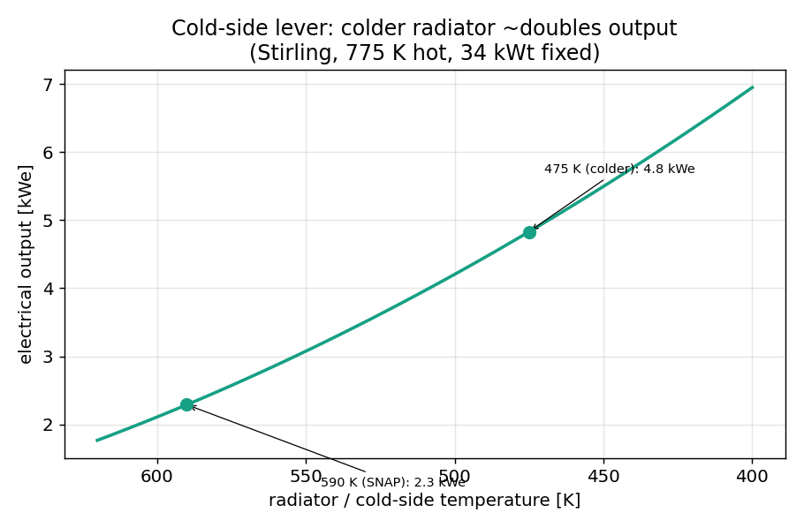
Figure 4. The cold-side lever. Holding the 775 K hot side and 34 kWt fixed and lowering the radiator from SNAP’s 590 K to 475 K roughly doubles a Stirling’s output, from 2.3 to 4.8 kWe, because a colder cold end widens the Carnot span. The cost is paid in radiator area.
The product of the three, roughly four and a half times two times two and a half, is about 22, which is the span from 0.58 to about 13 kWe. The first two multipliers are solid against the converter model. The whole uncertainty sits in the third, the uprate, because it is bounded by the coolant, the cladding, and the pump rather than by the fuel, and those limits have not yet been computed.
Two routes to 14 kWe
There are two distinct ways to close the gap, and they trade reactor power against temperature and radiator size. The same-hardware uprate, route A, keeps SNAP’s reactor, fuel, and size, runs it harder to about 85 kilowatts thermal, swaps to a Stirling, and runs a colder 475 K radiator. The model gives 13.0 kWe, at the cost of a radiator near 29 square meters, five times SNAP’s. The hotter redesign, route B, raises the hot side to KRUSTY’s 1050 K with sodium heat pipes and refractory hot-end materials and grows the core modestly to 56 kilowatts thermal. It gives 14.1 kWe with a smaller 17 square meter radiator, because the hotter hot side lifts the overall efficiency to 27 percent, but it requires a new heat-transport architecture rather than SNAP’s pumped NaK loop.
Route | Hot / cold (K) | Reactor power | Overall eff. | Radiator | Output
Flown thermoelectric | 775 / 590 | 34 kWt | 1.82% | 5.8 m2 | 0.58 kWe
SNAP + Stirling | 775 / 590 | 34 kWt | 7.2% | 5.4 m2 | 2.3 kWe
+ colder radiator | 775 / 475 | 34 kWt | 15.1% | 11.7 m2 | 4.8 kWe
A: same-hardware uprate | 800 / 475 | 85 kWt | 16.4% | 28.9 m2 | 13.0 kWe
B: hotter redesign | 1050 / 475 | 56 kWt | 26.8% | 16.6 m2 | 14.1 kWe

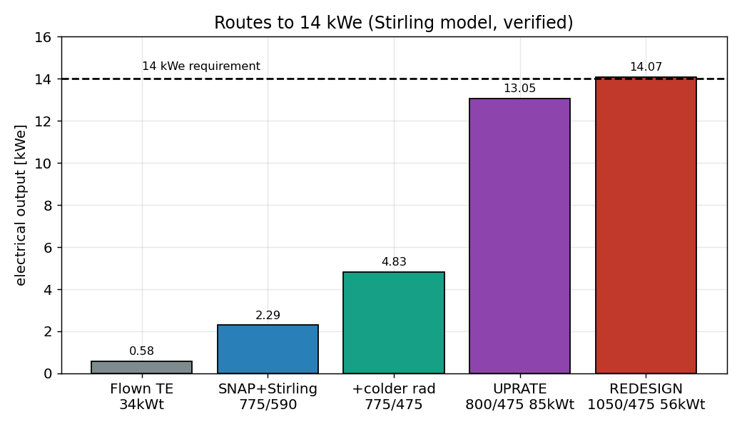
Figure 5. Routes to 14 kWe. Stacking the converter swap, a colder radiator, and a thermal uprate carries the system from the flown 0.58 kWe to the requirement. Route A reaches 13.0 kWe by uprating the existing core to 85 kWt; route B reaches 14.1 kWe by running hotter at 1050 K on less reactor power.
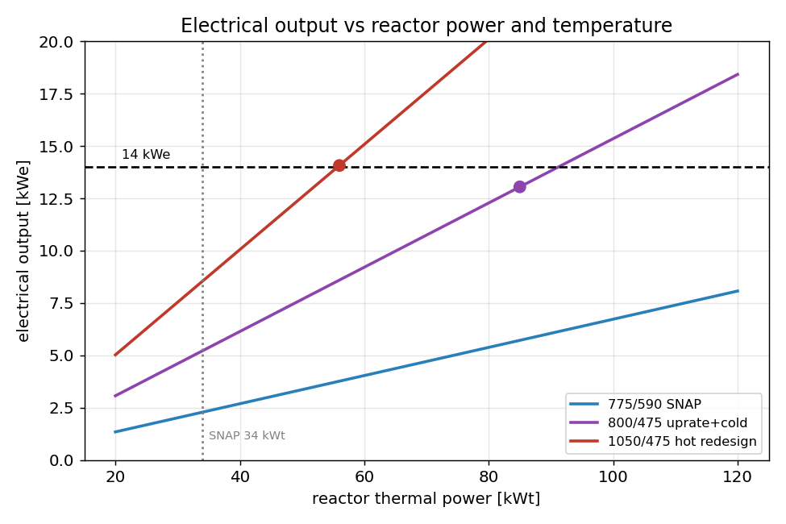
Figure 6. Electrical output against reactor thermal power for three temperature pairs. Hotter operation (the red 1050 / 475 K line) reaches 14 kWe at much lower reactor power than SNAP’s temperatures, which is why temperature, not just reactor size, does the work.
The contrast is the whole decision. Route A reaches the target at lower temperature but higher power and a much larger radiator. Route B reaches it at higher temperature with less power and a smaller radiator, paying for it with a new architecture. Temperature does real work in both, since every path that reaches 14 kWe at modest reactor power is a hot one.
The binding study: the thermal-hydraulic uprate ceiling
Both routes lean on the thermal uprate, route A entirely and route B partly, and the uprate is the soft assumption in the whole chain. Turning the assumed two to three fold into a computed number is a job for the coupled reactor model rather than a rule of thumb. The approach is to hold the hot side near 800 K and push reactor power up until a real limit bites: the peak fuel temperature against the roughly 970 K hydride wall, the peak cladding against its own limit, or the required NaK flow against what the electromagnetic pump can deliver into a rising pressure drop. The early analytic result is encouraging, with peak fuel near 867 K at 34 kWt and still under the wall at 46, which is the first quantitative sign that headroom exists. But the binding limit is set by the pump and the cladding, and it has to be found by the coupled run, not assumed.
What that single number decides is the route. If the existing core can be uprated to about 85 kWt at 800 K, then 14 kWe needs the same reactor run harder plus a Stirling plus a colder radiator, and the hotter redesign becomes optional. If the pump or the cladding caps the uprate nearer 60 kWt, the achievable output lands around 9 to 11 kWe on the existing core and the hotter redesign is back on the table. Either way the uprate ceiling is the decision, and it is a computed result rather than an assumption.
The reliability trade to keep in view
Everything here is efficiency, power, and mass, and the Stirling-plus-uprate path wins on all three. It buys that with moving parts in a machine that has to run untended for years, which is the reliability problem SNAP avoided in 1965 by going solid state. KRUSTY answered it with many small converters and redundancy, one per heat pipe, so a single failure is survivable. Any 14 kWe design on this path inherits both the reliability problem and that redundancy answer, and taking it on should be a deliberate choice rather than a footnote.

[1] Martin Peehs et al., “Uranium, Uranium Alloys, and Uranium Compounds,” in Ullmann’s Encyclopedia of Industrial Chemistry, 1st ed., ed. Wiley-VCH (Wiley, 2007), https://doi.org/10.1002/14356007.a27_281.pub2.
[2] Khanh Chau Le et al., “Theory of Transition from Brittle to Ductile Fracture,” arXiv:2303.08478, preprint, arXiv, May 6, 2023, https://doi.org/10.48550/arXiv.2303.08478.
[3] Michael Tonks et al., “Unit Mechanisms of Fission Gas Release: Current Understanding and Future Needs,” Journal of Nuclear Materials 504 (June 2018): 300–317, https://doi.org/10.1016/j.jnucmat.2018.03.016.
[4] G. Beausoleil et al., “Designing Nuclear Fuels with a Multi-Principal Element Alloying Approach,” Nuclear Technology 210, no. 3 (2024): 511–31, https://doi.org/10.1080/00295450.2023.2236796.
[5] Atomics International, SNAP 10A Power Conversion System Design and Test, report NAA-SR-11955 (Canoga Park, CA: Atomics International, 1966), https://digital.library.unt.edu/ark:/67531/metadc1033338/.
[6] David I. Poston et al., “KRUSTY Reactor Design,” Nuclear Technology 206, sup1 (2020): S13–S30, https://doi.org/10.1080/00295450.2020.1725382.
[7] Marc A. Gibson et al., Kilopower Power Conversion System Design Concepts, NASA Technical Reports Server document 20200001569 (Cleveland, OH: NASA Glenn Research Center, 2020), https://ntrs.nasa.gov/citations/20200001569.
[8] NASA Glenn Research Center, KRUSTY Ground Test Results and Kilopower Power Conversion, NASA Technical Reports Server document 20180007389 (2018), https://ntrs.nasa.gov/citations/20180007389.

